- 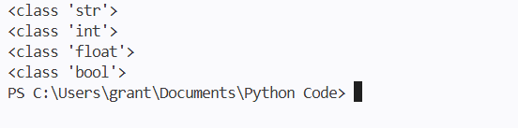

- 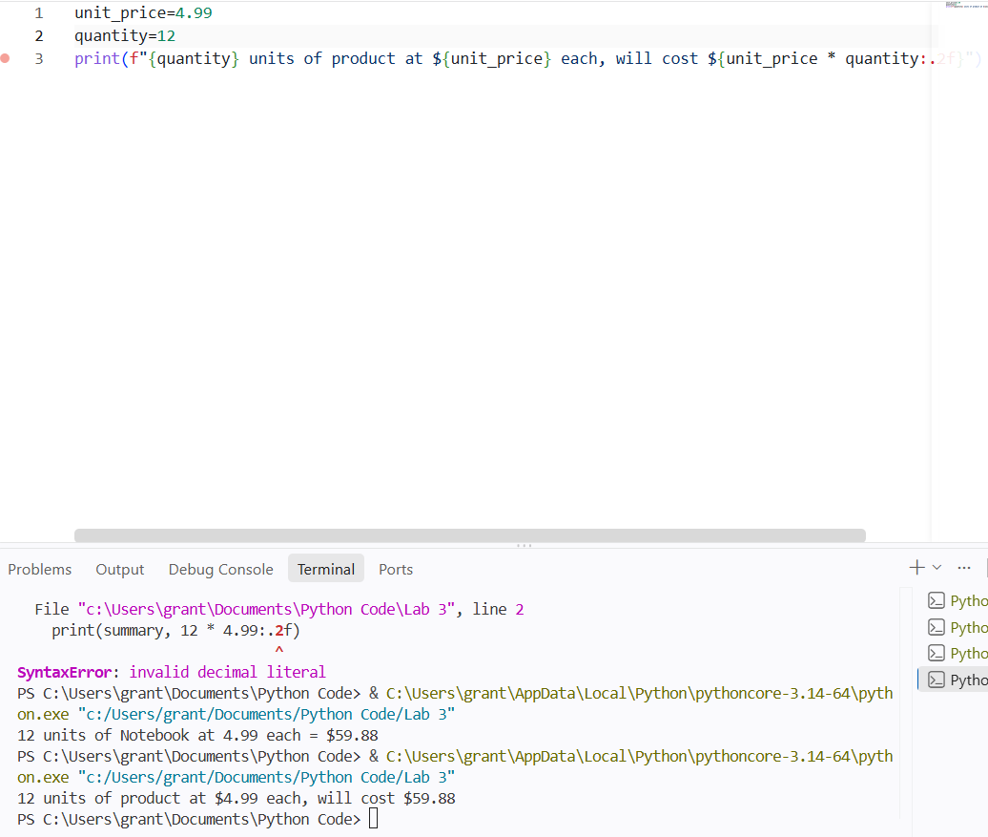

- 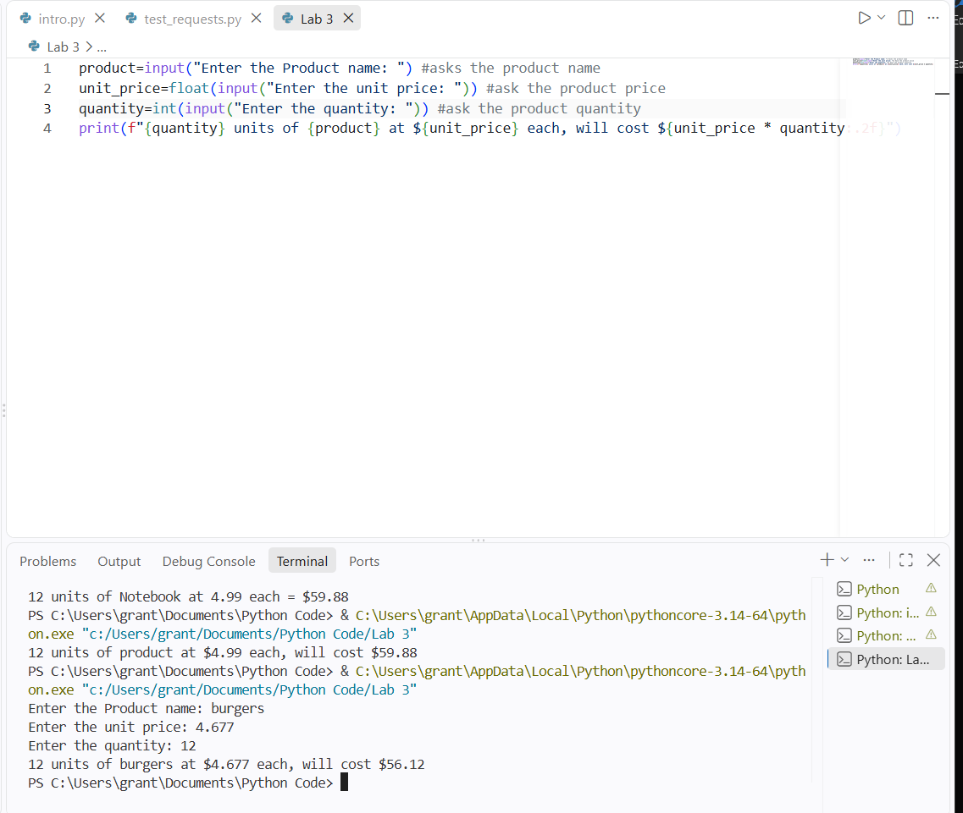

- 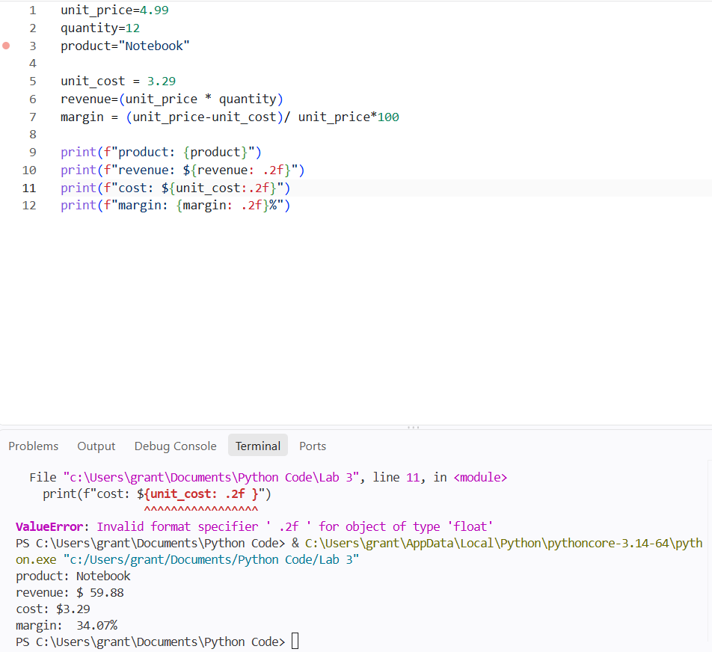

5.) python handles these very differently. If it is a string it will add one next to the other meaning 5+3=53 while if it’s a float or an int it will mathematically add them meaning 5+3 you get 8 or 8.0

6.) the code errors Name Error. because im trying to do calculations on a variable I have not given a value to. So when im asking the code to add “thing 1 and Thing 2” without defining thing 2 than it does not know what to add meaning it errors.

7. product1="Burger"
price1=4.99
cost1=3.99
margin1=(price1-cost1)/price1*100

product2 ="Fries"
price2=2.49
cost2=1.49
margin2=(price2-cost2)/price2*100

product3 = "Soda"
price3=1.99
cost3=0.99
margin3=(price3-cost3)/price3*100

print(product1)
print(f"${price1:.2f}")
print(f"${cost1:.2f}")
print(f"{margin1:.2f}%")
print("--------------------")
print(product2)
print(f"${price2:.2f}")
print(f"${cost2:.2f}")
print(f"{margin2:.2f}%")
print("--------------------" )

print(product3)
print(f"${price3:.2f}")
print(f"${cost3:.2f}")
print(f"{margin3:.2f}%")
print("--------------------")

print(f"product with the highest margin is {product1 if margin1 > margin2 and margin1 > margin3 else product2 if margin2 > margin1 and margin2 > margin3 else product3}")

8.) I
f"{1234567:.2f}", prints 1234567.00 with 2 empty decimal points since 2f
f"{1234567:,.0f}", prints 1234567 with no decimal points since 0f
f"{0.3456:.1%}", takes the initial number times 100 so because 0,3456 times it by 100
f"{42:05d}", takes point of data and only 5 points so since 05d and 42 is only 2 points add 3 0 in the front
f"{'hello':>20}". Prints hello 20 points from the left moving it off the far left

34.6%
00042
hello

